**Steps to Create and Run Application in Salesforce**

Sign up to Salesforce using the following link:

[**https://developer.salesforce.com/signup**](https://developer.salesforce.com/signup)

After signing up go to **Setup** and click on **Developer Console**.

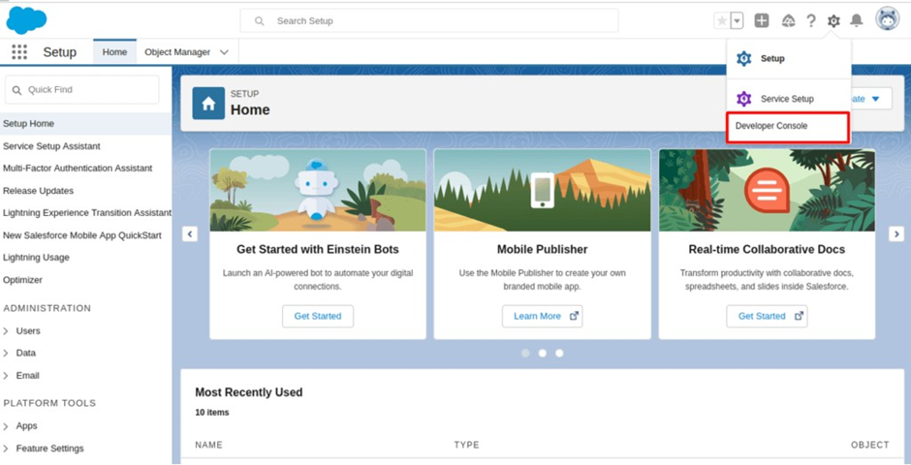

Now, in Developer Console click on File -> New -> Apex Class and Name it as Calculator

Note: If your Apex Class is disabled then signup through the given link: <https://developer.salesforce.com/signup>

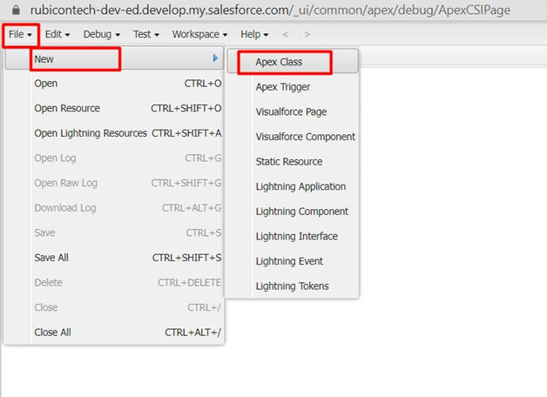

Now, in Developer Console click on File -> New -> VisualForce Page and Name it as Calculator

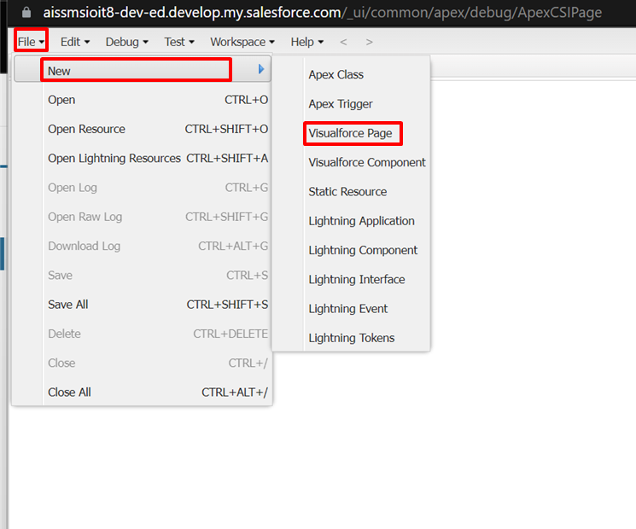

Now, Click on Preview Page to display the page.

